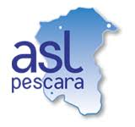

UNIVERSITA’ DEGLI STUDI “G. d’Annunzio”
Chieti-Pescara
SCUOLA SUPERIORE “G. d’Annunzio”
DOTTORATO DI RICERCA IN “INNOVATIVE TECHNOLOGIES IN CLINICAL MEDICINE AND DENTISTRY”
CICLO XXXVII
“Endothelial cells generation
from amniotic fluid stem cells-derived induced pluripotent stem cells (iPSCs)
as the basis for
a new in-vitro model of alveolar epithelial/endothelial co-culture.”

Dipartimento di Tecnologie Innovative in Medicina e Odontoiatria
Settore Scientifico Disciplinare MED/18

Dottorando Coordinatore
Dott.ssa Maria Enrica Miscia Prof. Sergio Caputi

Tutor
Prof. Gabriele Lisi

Anni Accademici 2022/2025

ABSTRACT
PURPOSE: The alveolus is the functional unit of the lung. It consists of flattened AT1 cells, responsible for the gas exchange, and cuboidal AT2 cells, which produce surfactants. Alongside AT1 and AT2 cells, endothelial cells (ECs) of the capillaries help form the air-blood barrier which enables gas exchange.Disruption of alveolar development can lead to lifelong lung disease in newborns and children. In vitro models that recapitulate the endothelial-epithelial crosstalk are currently missing. The aim of this study is to develop a novel in-vitro model of alveolar development from amniotic fluid stem cells to better understand the pathogenesis of congenital lung diseases.
METHODS: We optimized an established differentiation protocol to derive ECs from an amniotic fluid stem cell-derived hiPSC line. Human alveolospheres (hAO) were generated from reporter hiPSCs (NKX2.1-GFP/SFTPC-TdTomato) according to established protocols. As proof of concept for lung organoid and EC co-culture, we used HUVEC cells overexpressing ETV2 (RVECs), carrying an EGFP reporter to test media formulation that can support the co-culture and enable monitoring tubulogenesis. Results of the differentiation and the co-culture were monitored through brightfield images, immunostainings, flow-cytometry, and qPCR.
RESULTS: HiPSC-ECs differentiation resulted in clear morphological changes with visible transition away from hiPSC colony phenotype. Flow cytometry of hiPSC-ECs at day 11 revealed variable differentiation efficiency ranging from 1% to 12% CD31/CD34 double-positive cells (Figure A). Supplementation of bFGF and Heparin to RVECs culture in lung epithelial expansion medium resulted in an increase of the area covered by cells-forming tubules. The co-culture of hAOs and RVECs showed a progressive integration of endothelial cells with 3D lung organoids as resulted by immunostaining analysis (Figure B) as well as in the upregulation of AQP5 (AT1 marker) and SFTPC (AT2 marker) gene expression.
CONCLUSION: We developed an efficient protocol for differentiating amniotic fluid stem cells-derived hiPSCs into hiPSC-ECs. We also developed a proof-of-concept experiment for co-culturing endothelial and lung epithelial organoids in 3D. Our in-vitro model of distal lung development will be useful to model and better understand the pathogenesis of newborn children lung diseases in vitro.
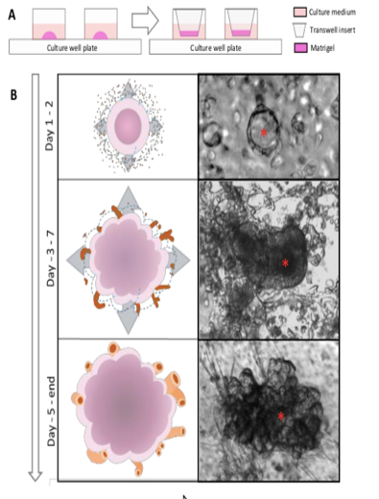
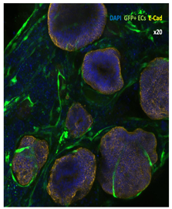
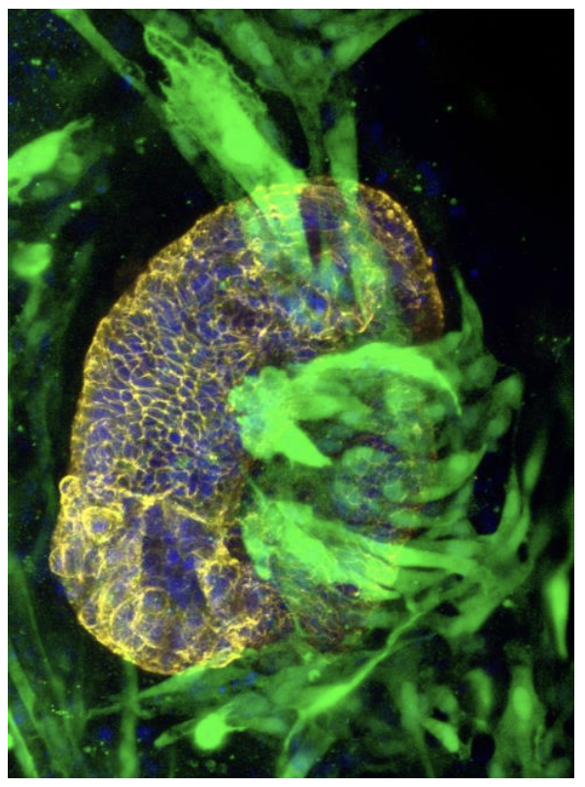
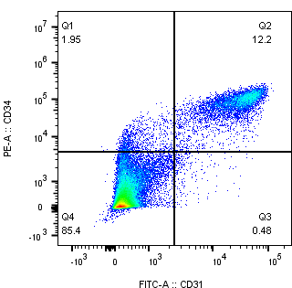
GFP ECAD NUCLEI
B. Epithelial-endothelial co-culture
A. HiPSCs endothelial differentiation
50 µm

SUMMARY
- INTRODUCTION
  - EMBRIOLOGY
    - Embriology of the cardiovascular system
    - Embriology of the lung
  - ROLE OF THE ENDOTHELIAL CELLS
    - Blood-gas barrier
  - TISSUE CULTURE
    - Endothelial generation
    - 3D cultures: Alveolar Organoids (AO)
    - Alveolar organoids as disease model
- AIM OF THE STUDY
- MATERIALS AND METHODS
  - ENDOTHELIAL CELLS (EC) GENERATION
    - Sorting protocol
  - ALVEOLAR ORGANOIDS (ALVEOLOSPHERES, AO) GENERATION
  - RESET-VASCULAR ENDOTHELIAL CELLS
  - CO-CULTURE EXPERIMENTS
- RESULTS
  - EC GENERATION
  - ALVEOLOSPHERES GENERATION
  - CO-CULTURE EXPERIMENTS
- CONCLUSIONS
- REFERENCES

- INTRODUCTION

1.1 EMBRIOLOGY
1.1.1 Embriology of the Cardiovascular System
The cardiovascular system is the first to develop and become functional in the human embryo [1,2].
During the first two weeks of development, the nourishment of the embryo is achieved by diffusion from the maternal blood.
Starting from the 3rd week, however, the increasing needs of the rapidly growing embryo stimulate the development of the cardiovascular system.
The process that allows the “de novo” blood vessels formation is called “vasculogenesis”. The extraembryonic vasculogenesis starts about 2 days earlier than intraembryonic vasculogenesis, when mesenchymal cells differentiate into endothelial cell precursors, called angioblasts.
The first stage of vasculogenesis is the aggregation of angioblasts to form “angiobastic cords” or “aggregates”. The angioblasts, then, flatten to form endothelial cells and the angioblastic cords become fluid-filled vesicles called “blood vessel islands”. These cavities lined by endothelium fuse with the neighboring to form the “primary vascular plexus”, whose structure resembles the sinusoid vessels of the spleen.
These primordial vessels are only lined by endothelium; later on, in the embryonic development, vessel remodeling and maturation occur to respond to pressure stimuli. In fact, smooth muscle cells and fibroblasts are recruited to strengthen the wall of the vessels forming the tunica media and the adventitia.
Together with the vasculogenesis, during the 3rd week the heart develops from the mesenchymal cells in the cardiogenic area: paired endothelial lined chambers fuse to form the primordial heart tube.
At the end of the 3rd week the heart is beating and the blood is circulating in the embryo, forming a primordial uteroplacental circulation.
After vasculogenesis, remodeling and vascular formation from pre-existing vessels take place and this process is called angiogenesis.
Angiogenesis occurs through sprouting, intussusception, fusion or regression of vessels (figure 1).

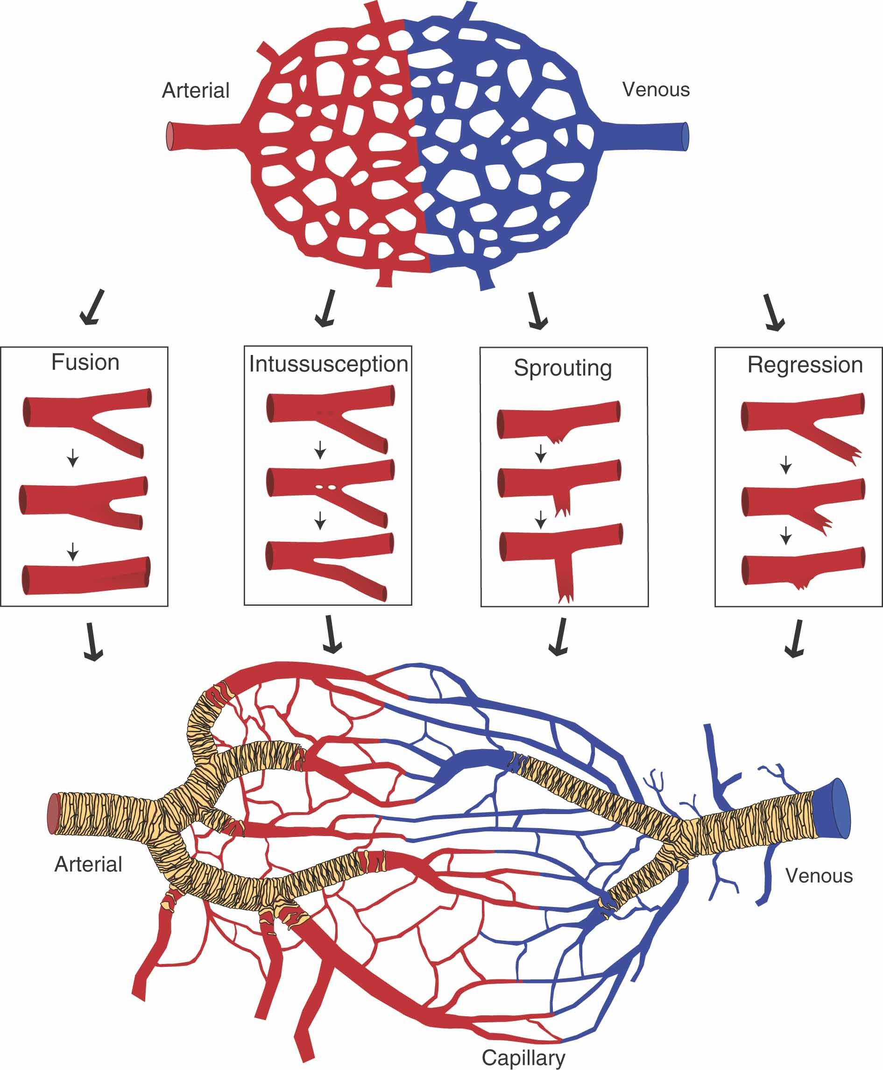
Figure 1
Mechanisms of Angiogenesis

1.1.2 Embriology of the Lung
Lung development starts around the 3rd week of gestation and has a prenatal and post-natal phase. During morphogenesis the lung changes from a gland-like structure to an open, alveolar structure [1, 3-6].
Prenatally, the respiratory system develops from the 4th pharyngeal pouch, as laryngo-tracheal groove. This groove is the primordial tracheabronchial tree, whose endoderm will give rise to the pulmonary epithelium [1].
By the end of the 4th week, the lung buds appear and progressively elongate to form the respiratory buds.
These respiratory buds divide to form the primary bronchi at the beginning of the 5th week of gestation (figure 2) [1].

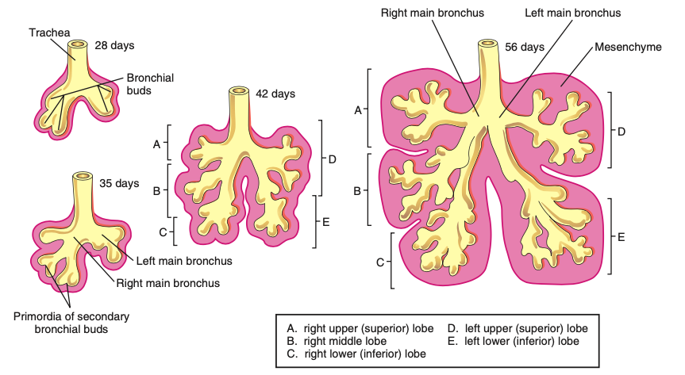

Figure 2
Embriology of the bronchial tree. Adapted from Moore et al.

Maturation of the lung goes through four, partially overlapping, stages (figure 3) [1, 6]:
- Pseudoglandular
- Canalicular
- Saccular
- Alveolar
During the pseudoglandular stage (from 5 to 17 weeks of gestation (GA)) there is a progressive branching of the bronchi to form the primitive airways and the acinar tree. By the end of this stage all the lung structures but those for the gas exchange are formed.
The canalicular stage [16-26 week GA) is characterized by the expansion of the lumen of the bronchial tree to generate the respiratory bronchioles, which divide to form the primordial alveolar ducts.
During the saccular stage (26 week GA-birth) many more terminal sacs develop, which are surrounded by capillaries. The intimate contact between the epithelium forming the saccules and the endothelial cells of the respiratory capillaries establishes the blood-air barrier, which is responsible for the gas exchange. During this stage also the alveolar epithelium matures: the saccules are lined by flat alveolar type (AT) 1 cells, while the cuboidal AT2 cells produce surfactant. The production of the surfactant starts around the 22nd week, however it is very scarce until birth. Moreover, the AT2 cells play the role of lung stem cells, capable to differentiate into AT1 cells.
The alveolar stage starts at around 32 weeks of GA and it continues after birth. During this stage there is an explosion of production of alveoli and the lung becomes not only functionally but also structurally mature (i.e. it undergoes complete maturation). About 95% of all the alveoli are produced postnatally. It is not well established when the alveolar stage ends: some state it ends by the age of 8 [1, 7], Burri et al. suggested it stops at the age of 1-2 years [8], while Schittny et al. proposed that alveologenesis continues until the age of 18 years, whit the most part of alveolar production occurring between 3 and 18 years of age [9].
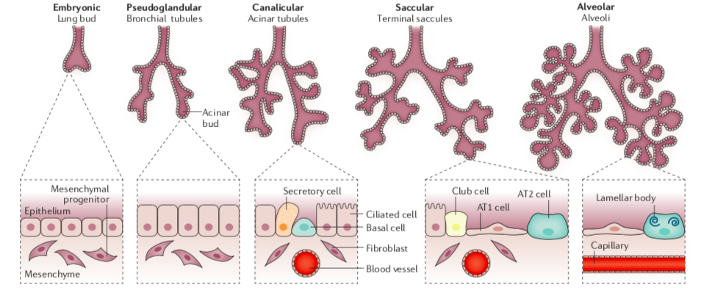

Figure 3
Schematic illustration of the lung development. Adapted from Thébaud B et al. Nature Review 2019.

1.2 ROLE OF THE ENDOTHELIAL CELLS
Blood vessels play a pivotal role in physiological and pathological mechanisms; in fact, they are involved in the generation and repair of the organs but also in the progression of many diseases, such as cardiovascular diseases, congenital vascular diseases and tumorigenesis [10,11].
The innermost layer of the blood vessels is made by a monolayer of endothelial cells (ECs), which are therefore directly in contact with the bloodstream (figure 4) [12].

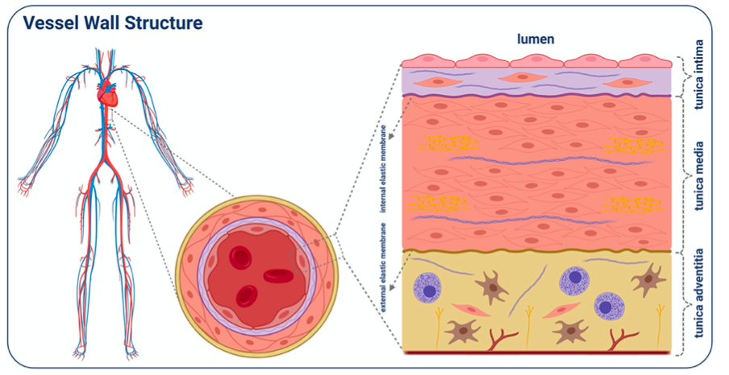

Figure 4
Image of the vessel structure. Adapted from Trillhaase et al. Stem Cell Reviews and Reports (2021).

ECs play an important role in maintaining tissutal homeostasis: they are involved in vasodilation and vasoconstriction and have signaling functions through the production of angiocrine factors [10-12].
Altered ECs contribute to fibrosis and tumor progression [13].

1.2.1 Blood-gas barrier

ECs are fundamental for the correct function of the blood-gas barrier, also known as alveolo-capillary barrier.
The blood-gas barrier of the alveolus is the functional element of the lung, composed by the pulmonary epithelial cells (alveolar cells type 1 and 2; AT1,2), the endothelial cells of the alveolar capillaries and the mesenchymal cells laying in the extracellular matrix (fibroblasts, smooth muscle cells, pericytes) (figure 5) [4-6, 14].

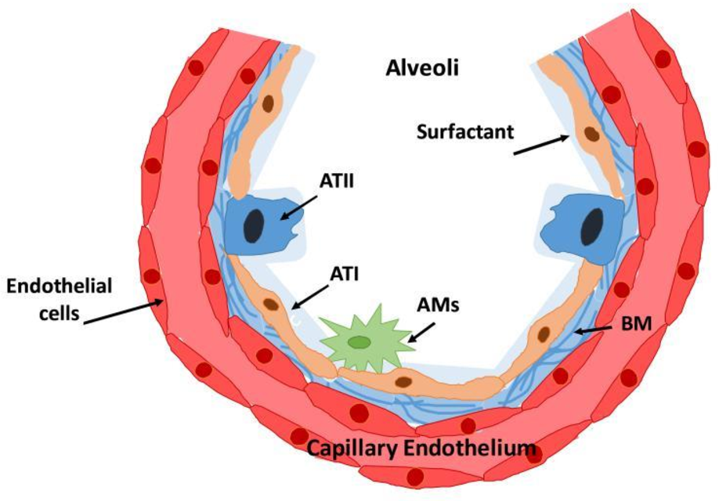

Figure 5
Schematic illustration of the blood-gas barrier, showing the interaction among the different cells and the basal membrane (BM). AM: mast-cells. ATI: alveolar type 1 cells. ATII: alveolar type 2 cells.

The blood-gas barrier is not only a mere physical barrier but rather a complex and dynamic structure which allows the diffusion of gases (O2, CO2), regulates the permeability of the alveolus and is capable to respond to external stressors.
The interaction among all the cellular components of the barrier is possible through a complex paracrine activity.
In this context, ECs play a pivotal role not only in regulating the permeability of the barrier, but also in lung regeneration and healing through the stimulation of the angiogenesis and by extension the induction of alveolar growth and remodeling also inducing the differentiation of AT2 into AT1 cells. [3,14].

Any disruption of this fragile equilibrium leads to the development of several congenital or acquired diseases, such as pulmonary hypoplasia (mainly secondary to congenital diaphragmatic hernia), pulmonary hypertension, bronchopulmonary dysplasia, pulmonary edema and many others (figure 6).

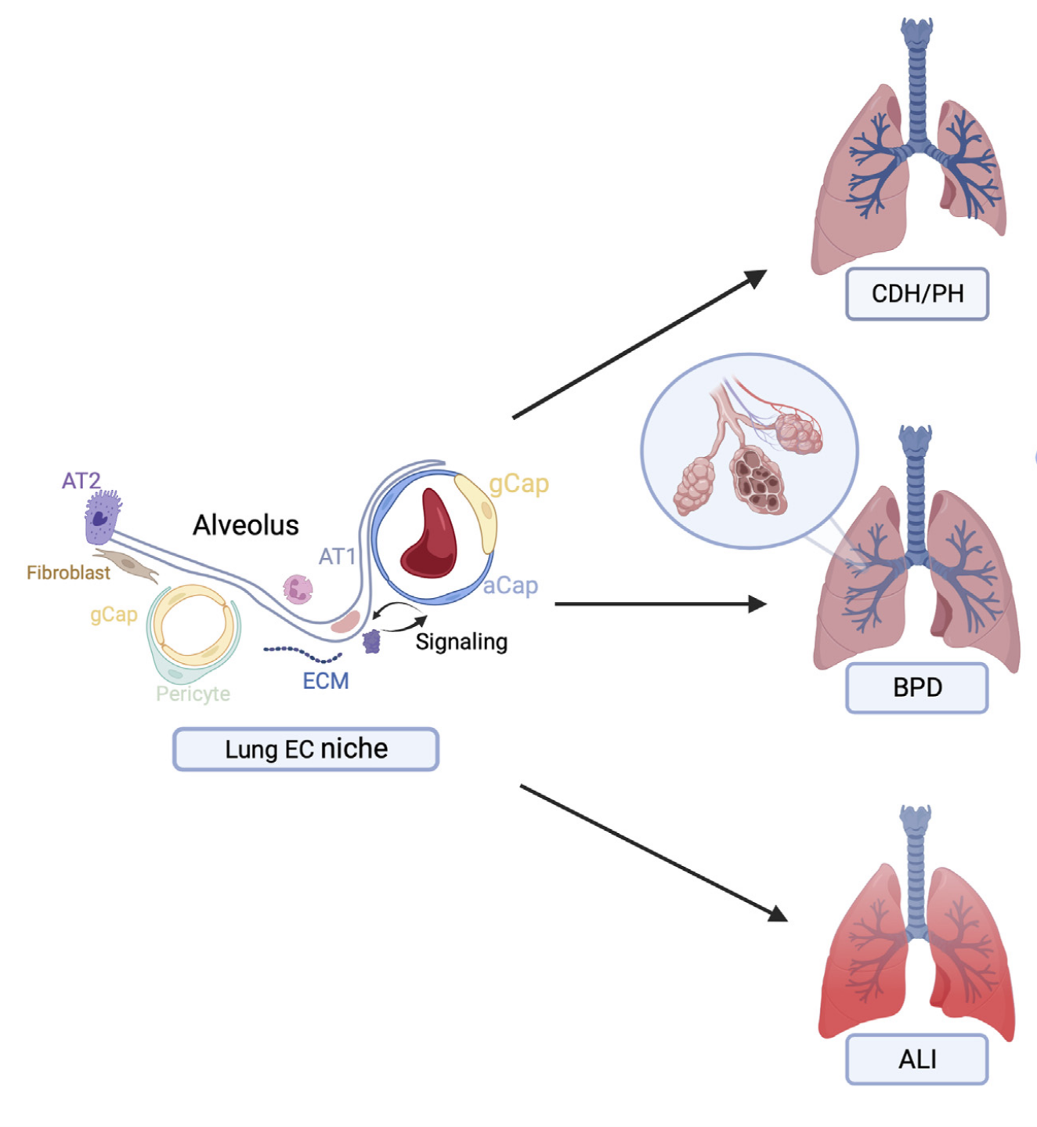
Figure 6
Disruption of the equilibrium in the blood-gas barrier lead to congenital lung diseases. Adapted from Tsikis et al. Frontiers Mol Bio 2022 and Thébaud B et al. Nature review 2019

1.3 TISSUE CULTURE

1.3.1 Endothelial generation

Due to the important role of ECs in physiological and pathological pathways, many efforts have made to produce ECs which could be cultured in vitro.
For decades, human umbilical vein ECs (HUVECs) have been the gold standard in ECs research because they were easily accessible [15].
More recently, Endothelial Progenitor Cells (EPCs) from cord blood or even from adult peripheral blood have been proposed, however they are not easly accessible in healthy donors [15,16].
The derivation of healthy and patient-specific ECs has been always difficult and only a few models of vascular cells are available up-to-now [12,15].
Starting from the early 2000s, the discovery of induced pluripotent stem cells (iPSCs) allowed the production of patient-specific ECs to study physiological and pathological mechanisms and the response to drugs [17].
Briefly, iPSCs are adult somatic cells which are reprogrammed by forced expression of pluripotency factors [12]. They have the advantage to ideally allow the generation of different cell types from the same reprogrammed cells of a single individual [12,14,15].
Many protocols of ECs differentiation from iPSCs have been proposed.
The first to obtain iPSCs-derived ECs were Choi et al and Taura et al. in 2009 using a co-culture of iPSCs and mouse bone marrow stromal cell lines [18, 19]. Even though those ECs had good features in terms of surface markers, tube formation and cell behavior, the total differentiation efficiency was low and the use of animal feeder made them impossible to translate the protocol in human research [12].
In 2010 the groups of Park et al and Homma et al. independently obtained ECs without using animal feeder and they found that mesoderm induction was a key step for EC generation [20, 21].
In 2014, the group of Orlova at al. showed that the GSK3-ihibitor CHIR99021 alone was able to induce mesoderm differentiation obtaining ECs with a good efficiency. In 2017 Ikuno et al. added the cAMP to this protocol in order to try to increase its efficiency [11,15].
In the same year, Palpant et al. produced a very efficient protocol to obtain ECs, however it was very long and complicated [22].
The generation of 2D cultures of iPSCs-derived ECs, however, was insufficient to reproduce the “in vivo” environment. Therefore, more recently 3D tissue cultures (organoids) and tissue models have been developed from iPSCs to resemble many organ structures and function.

1.3.2 3D cultures: Alveolar organoids (AO)

The increasing need to find models that allow to study the pathophysiology of many congenital and acquired diseased has led to the generation of 3D multicellular models, the so-called organoids [12,14].
iPSCs-derived alveolar organoids, also known as Alveolospheres, are spheroids which resemble the functional unit of the lung: the alveolus.
In 2019 Jacob et al published a Nature protocol which allowed to obtain stable AO starting from double reporter iPSCs [Jacob].
By reproducing the normal embryology of the distal lung, they firstly induced endodermal differentiation of iPSCs and then patterned the endodermal cells into anterior foregut primordial NKX2-1⁺ cells which were then differentiated into distal lung AT2 ( SFTPC⁺) cells [23].
The alveolospheres obtained by Jacob et al., however, were only made by AT2 cells, which are known to have a staminal function.
In order to obtain a more physiological model of the alveolus, many Authors tried co-cultures with mesenchymal and endothelial cells to stimulate an AT1 differentiation of the AT2 cells, to reach a normal AT1/AT2 ratio [14,24-26].
Inthis context, the 3D AOs were also used to understand the mechanisms underlying many congenital pulmonary diseases [27].

1.3.3 Alveolar organoids as disease model

As previously mentioned, the strong interaction among ECs, epithelial cells and mesenchymal cells allows the correct activity of the blood-gas barrier.
During the lung embryogenesis mesenchymal cells increase the expression of the Vascular Endothelial Growth Factor (VEGF) activating the VEGFR-2 (receptor), stimulating both the capillary formation and the alveolar budding. Thus, any disruption of the vascular development might results in congenital lung diseases [3, 26].
This statement leads to the idea that targeting the ECs to increase vasculogenesis and angiogenesis might have important implications in the treatment of several congenital lung diseases [3,4].
Therefore, the generation of vascularized AOs is of pivotal importance to understand all the pathways involved in the normal and abnormal pulmonary growth.

2. AIM OF THE STUDY

Endothelial Cells (ECs) play a pivotal role in lung maturation and regeneration through complex paracrine mechanisms which are not completely understood yet [3,4].
The blood/gas barrier (or alveolar/capillary barrier) is the functional unit of the lung composed by alveolar type 1 and 2 cells, endothelial cells and mesenchymal cells. It allows gas exchanges between the internal surface of the alveolus and the blood.
Any disruption of its equilibrium leads to several lung diseases (such as Pulmonary Hypoplasia, Pulmonary Hypertension, Bronchopulmonary Dysplasia, Respiratory Distress Syndrome) [3-6,14,26].
The use of human induced-pluripotent stem cells (hiPSCs) might help in generating a 3D model of the lung starting from the same cells which can be used to study the physiology and the pathology of the lung [12].
Up-to-now, a few optimized models of ECs generation from hiPSCs exist in literature which allow to obtain functioning ECs [11,15,22].
The aim of our study was therefore to optimize previously existing protocols of Endothelial Cells Differentiation using Amniotic fluid stem cells-derived iPSCs.
Moreover, as a proof-of-concept experiment, we differentiated human Alveolospheres (AOs) from iPSCs and we co-cultured them with reset-vascular ECs (RVECs) in order to produce an in-vitro model of alveolar differentiation.

3. MATERIALS AND METHODS

3.1 ENDOTHELIAL CELLS (EC) GENERATION
We used a line of amniotic fluid stem cell-derived iPSCs (H0220C) generated from the laboratory of Prof. De Coppi (Zayed Center of Research, UCL Institute of Child Health, London).
Starting from the protocol from Orlova et al. (2014) we generated structurally normal ECs as follows (figure 7):
- Day -4: iPSCs were passaged and seeded in 12 well plates at the density of 5-6 colonies/well and expanded in mTeSR+ Rho-kinase Inhibitor (RI) (StemCell Technologies). mTeSR was renewed daily without RI.
- Day 0: Mesoderm induction was started by replacing mTeSR with Mesoderm Induction Medium (MIM; B(P)EL + Activin A, BMP4, VEGF, CHIR) for 48 hours (tables X Y)
- Day 2: MIM was changed with Vascular Specification Medium (VSM; B(P)EL+ VEGF, SB431542) for 96hours (tables X Y)
- Day 6: refresh VSM
- Day 8 refresh VSM
- Day 10: refresh VSM
- Day 11: Sorting of ECs. Prepare gelatin-coated (0,1%) 6 well plates. After sorting, replate ECs into gelatin-coated wells with Complete EC-SFM (Gibco; tables 1 a-d) for expansion.

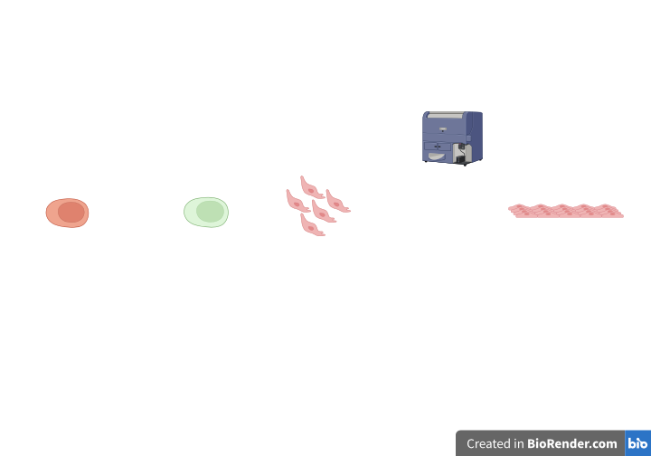
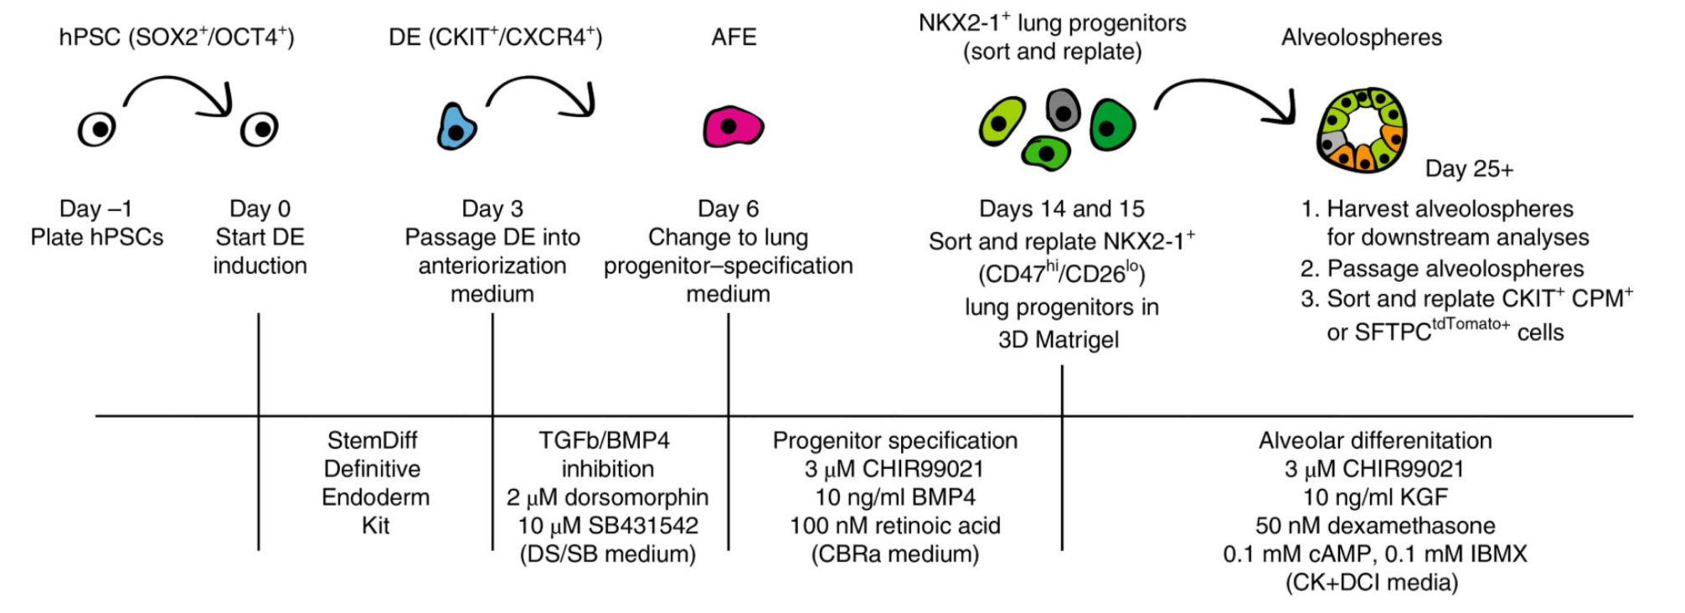
D (-)4
D0
D2
D10
D20
mTeSR
B(P)EL
Activin A (25 ng/ml)
BMP4 (50ng/ml)
CHIR99021 (1.5 µM)
B(P)EL
VEGF (50µg/ml)
SB431542 (10µM)
Complete EC-SFM
Cell Sorting
hiPSC
Vascular Specification
Endothelial Cells Expansion
Mesoderm Induction

Figure 7
Diagram showing the steps of ECs differentiation.

3.1.1 Sorting protocol:
- Split cells with TryplE for 5’ at 37°C
- Move the cells in a Falcon tube and suspend in DMEM+ 10%FBS
- Centrifuge tube at 300g for 5’ at 4°C
- Aspirate supernatant and resuspend pellet with DMEM+10%FBS
- Centrifuge tube at 300g for 5’ at 4°C
- Prepare antibodies (Ab) solution: we made 250uL PBS + 5uL CD31 FIT-C and 5uL CD34 PE
- Aspirate supernatant
- Resuspend pellet in 100uL Ab solution
- Incubate for 30-40’ in the fridge
- Make a solution of PBS+1%FBS
- Resuspend cells with the solution of PBS+1%FBS up to 14ml in a Falcon Tube
- Centrifuge tube at 300g for 5’ at 4°C.
- Aspirate supernatant
- Resuspend in 400uL PBS and move to a FACS tube

Table 1
from Orlova et al.
- B(P)EL medium: BSA polyvynilalchohol (P) essential lipids (in which P is eliminated)
Composition | Final concentration
1 × Iscove's modified Dulbecco's medium (IMDM)
1 × Ham's F-12 nutrient mixture
Protein Free Hybridoma Medium (PFHMII) | 5%
10% (wt/vol) BSA in IMDM (deionized) | 0,25%
Lipids (100×) | 1x
ITS-X (100×) | 0.1x
αMTG (13 μl in 1 ml IMDM) | 450 μM
AA2P (50 mg/ml) | 0.05 mg/ml
GlutaMAX (200 mM) | 2 mM
- Mesoderm Induction Medium (MIM)
Composition | Final concentration
B(P)EL
ActivinA | 25ng/ml
BMP4 | 30ng/ml
VEGF | 50ng/ml
CHIR | 1.5 μM
- Vascular Specification Medium (VSM)
Composition | Final concentration
B(P)EL
VEGF | 50ng/ml
SB431542 | 10 μM
- Complete EC-SFM medium
Composition | Final concentration
EC-SFM
VEGF | 30ng/ml
bFGF | 20mg/ml

3.2 ALVEOLAR ORGANOIDS (ALVEOLOSPHERES, AO) GENERATION
We used a double reporter line of iPSCs (BU3NGST NKX2-1^{GFP}/SFTPC^{TdTomato}) as per protocol by Jacob et al. (figure 8, table 2) [23].
Brefly:
- Precoat 6-well plates with 0.5%MRF in DMEM/F12 (2mL/well for 1h @RT). Expand hiPSCs in mTeSR medium (Stemcell Technologies). Add RI when thawing, then change medium daily without RI until 80% confluency.

- Day 0-1. When cells reach 80% confluency, commit cells to Endoderm by treating hiPSCs with RPMI 1640 (with Glutamax and HEPES 1X (or 25mM)) medium plus 1% p/s, 1% NEAA and 1x of 50x B27-supplement minus insulin supplemented with 100ng/mL Act-A, 20ng/mL bFGF, 10ng/mL BMP4 and 3µM CHIR-99021 for 1 day and with 100 ng/mL Act-A for 1 additional day, until cells reach 100% confluency.

- Day 2-5. At Day 2 split cells by washing twice with PBS-/-, then add 1mL TryplE and incubate 2min in the incubator. Collect cells in a tube and dilute with PBS-/-. Centrifuge @300g for 5min. Aspirate supernatant and resuspend in “DS/SB” medium supplemented with RI to split cells 1:7 in 1% MRF-coated 6-well plate. At Day 3 change medium by adding “DS/SB” without RI until Day 5.

- Day 6-15. Change CBRa medium every other day.

- Day 15-16. Sorting (2 wells). Wash twice with PBS-/- and incubate with 1mL TryplE for 5min or until complete cell detachment. Collect cells in a 15-mL tube, dilute with PBS and centrifuge @300g for 5min. Resuspend in 300uL FACS Buffer (0.5% BSA in PBS-/- + 2mM EDTA +RI) and transfer in FACS tubes. Prepare collection tube: 1.5mL Eppendorf with 300uL of “CK+DCI” +RI.
Add PBS to 1mL and centrifuge in the microcentrifuge @500g for 4min (or @1200g for 3min). Under the hood, remove supernatant and add MRF according to the number of cells (350-400 cells/uL). Plate cells in 24-well plate and add “CK+DCI” +RI (first 48h hours only).
Figure 8
Diagram showing the steps of Alveolospheres differentiation.

Tables 2
Media from Jacob et al.
- Complete serum-free differentiation medium (cSFDM)
Composition | Final concentration
IMDM
Ham’s F12
GlutaMAX | 1%
B27 supplement | 1%
7.5% BSA | 0.6%
N2 supplement | 0.5%
Ascorbic Acid | 50μg/ml
MTG | 4.5 × 10−4 M
Pen/Strep | 1%
- Lung progenitor–specification medium (CBRa)
Composition | Final concentration
cSFDM
CHIR | 3 μM
BMP4 | 10ng/ml
Retinoic Acid | 100 nM

- CK-DCI Medium
Composition | Final concentration
CI stock Medium
cSFDM
CHIR | 3 μM
FGF7 | 10ng/ml
Dexamethasone | 50 nM

3.3 RESET-VASCULAR ENDOTHELIAL CELLS (RVECs)
We used HUVEC cells overexpressing ETV2 (RVECs) as per Paliquki et al. carrying an EGFP reporter to test media formulation that can support the co-culture and enable monitoring tubulogenesis (figure 9) [13].
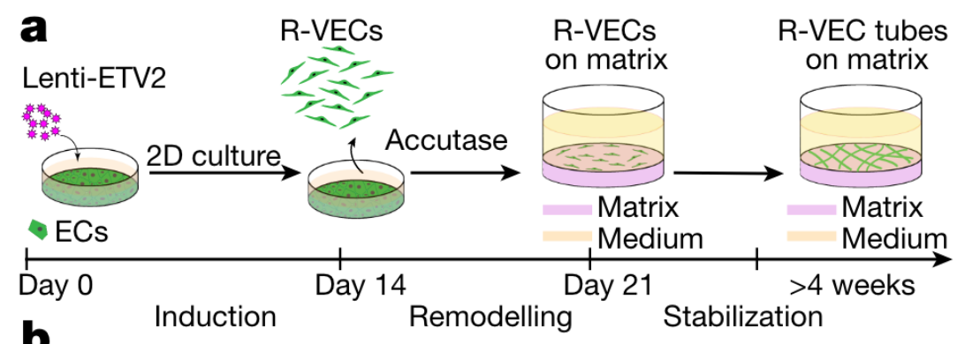

Figure 9
RVECs generation through transfection of ECs with a lentivirus carrying ETV2 gene. Adapted from Paliquki et al.

3.4 CO-CULTURE EXPERIMENTS

All co-culture experiments were performed in 3D Matrigel.
Roughly 200000 RVECs and about 30/40 AO of a diameter of 200-400μm were mixed and seeded in 24-Transwell plates (Falcon).
The expansion and differentiation media used were those optimized by Benoist et al. (unpublished data) starting from Paliquki et al. and Jacob et al media in order to obtain higher tubularization (figure 10).

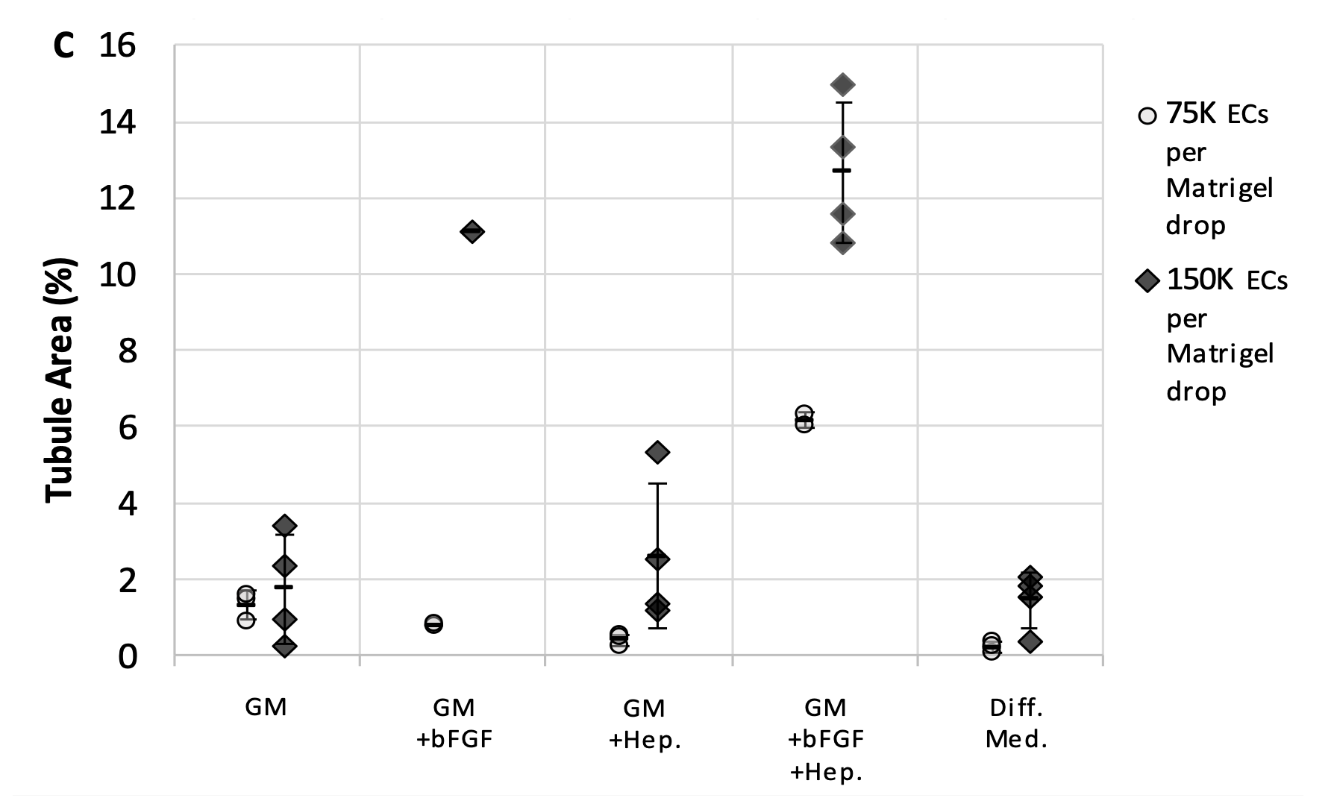
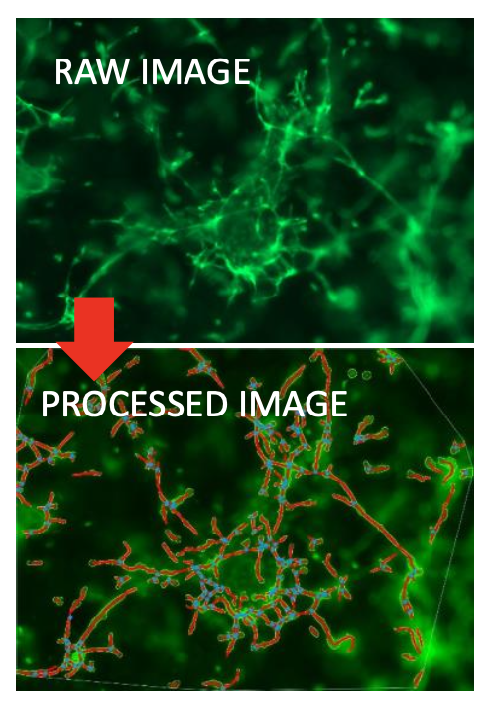

b
a

Figure 10
a.EC tube formation was quantified for various culture conditions using the software AngioTool. b. EC tube area percentage was quantified for RVECs cultured in lung epithelial culture media with or without bFGF and heparin, and in lung epithelial differentiation medium.

Based on the results, we used AO expansion and differentiation media added with bFGF, heparine and VEGF, to allow EC growth.
Results of the differentiation and the co-culture were monitored through brightfield images, immunostainings, flow-cytometry, and qPCR.
RESULTS
4.1 EC GENERATION
The experiment was performed in 3 replicates.
Starting from D2 of differentiation, iPSCs showed morphological changes visible at brightfield (figure 11).
Differentiated cells were sorted at D10 or D11, according to confluency, in order to isolate the endothelial-like cells.
Cells were sorted for the CD31⁺ and CD34⁺ and we could find a clear subset of double positive cells (average 11%; range 12.2%-9%) indicating the presence of endothelial-like cells following differentiation (figure 12).
Double CD31⁺/CD34⁺ cells were then replated and expanded in vitro and resembled the morphology of the control HUVECs (human umbilical vein ECs) (figure 11).
Additional characterisation now underway (immunostaining, qPCR) to confirm endothelial cell identity and phenotype.

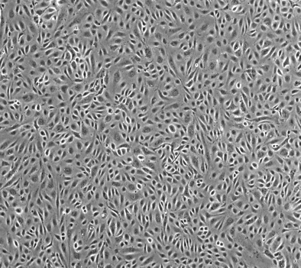
(reference HUVECs)

Reference HUVECs
Figure 11
Brightfield images of differentiation process. Expanding ECs in 0.1% gelatin coated wells resemble the morphology of referenc HUVECs.
Figure 12
Gating strategy on flow cytometry to sort CD31⁺/CD34⁺ double positive cells.

4.2 ALVEOLOSPHERES GENERATION
Starting from D1 of differentiation, the iPSCs were committed to endoderm until 100% confluency.
At D2 cells were splitted 1:7 and reseeded with DS/SB medium until D5, then medium was changed to lung specification medium (CBRa).
At D15 cells were confluent and could be sorted for the NKX2-1⁺ positive cells. During the entire process a change of morphology can be observed at brightfield (figures 13,14).

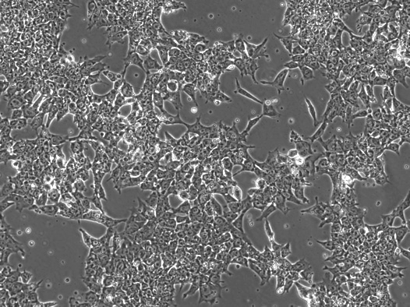
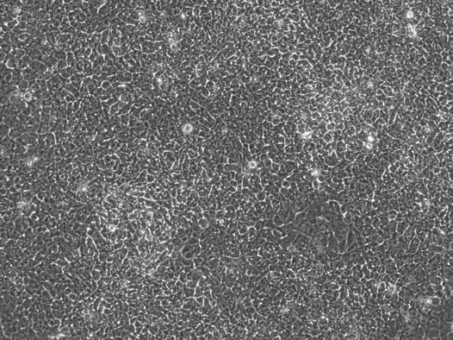
D2
D1
10x

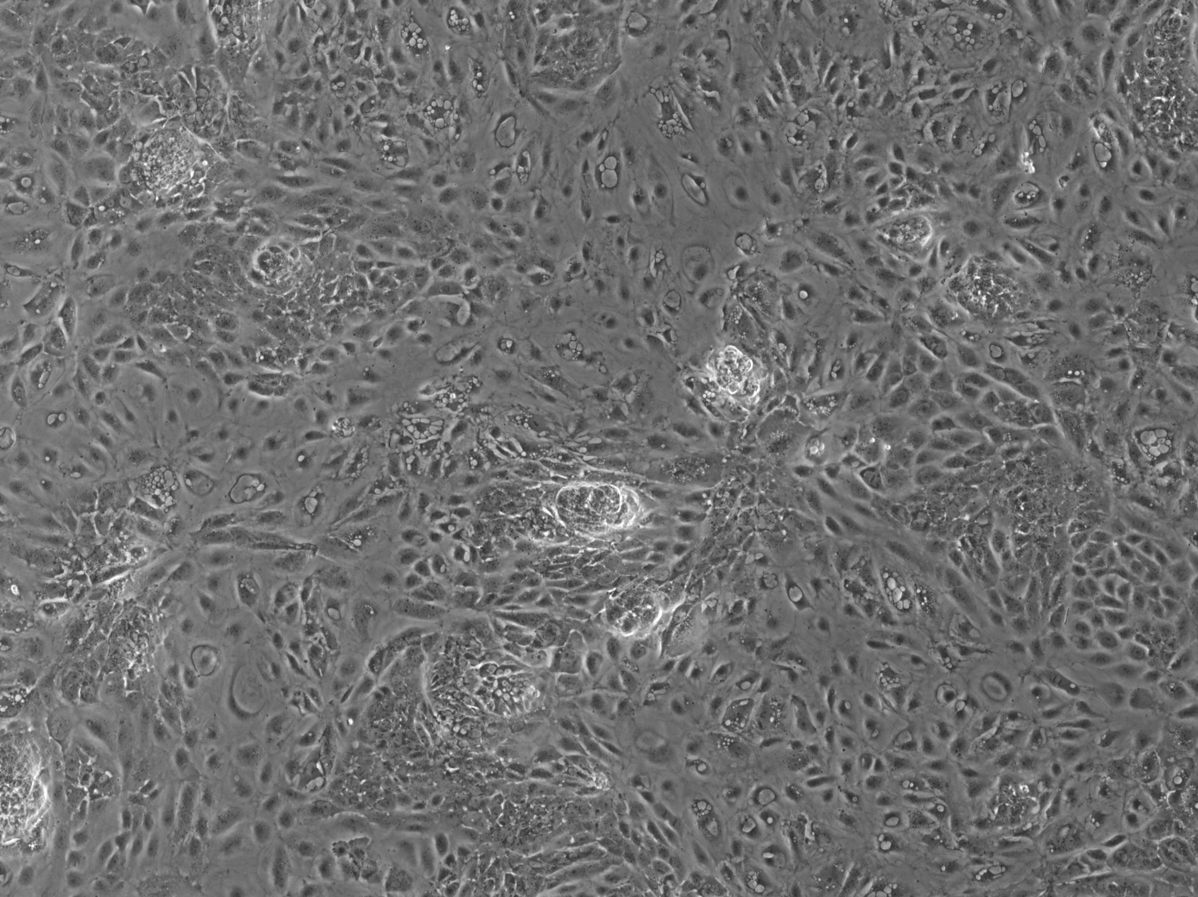
D15
D3

Figure 13
Brightfield images of endoderm (D1-2) and lung (D3-D15) induction of iPSCs.

After sorting, a 40% of NKX2-1⁺ cells was found and used to generate AOs on 3D Matrigel culture.

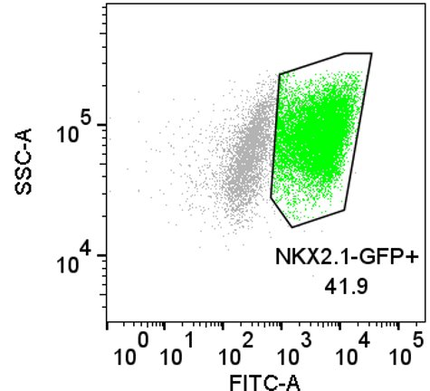

Figure 14
Cell sorting of lung NKX2-1⁺ progenitor cells.

After a few days of culture, AOs appear expressing the distal AT2 marker SFTPC, as shown at fluorescence microscopy (figure 15).
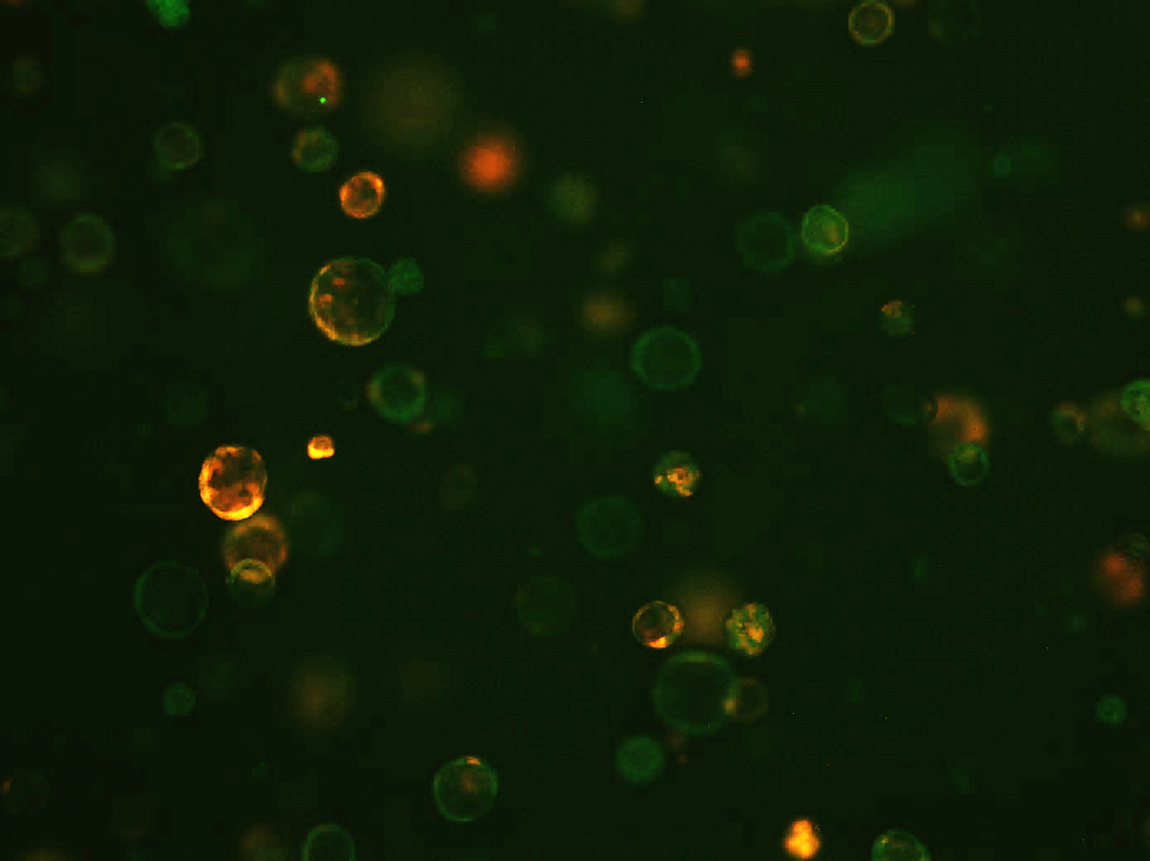
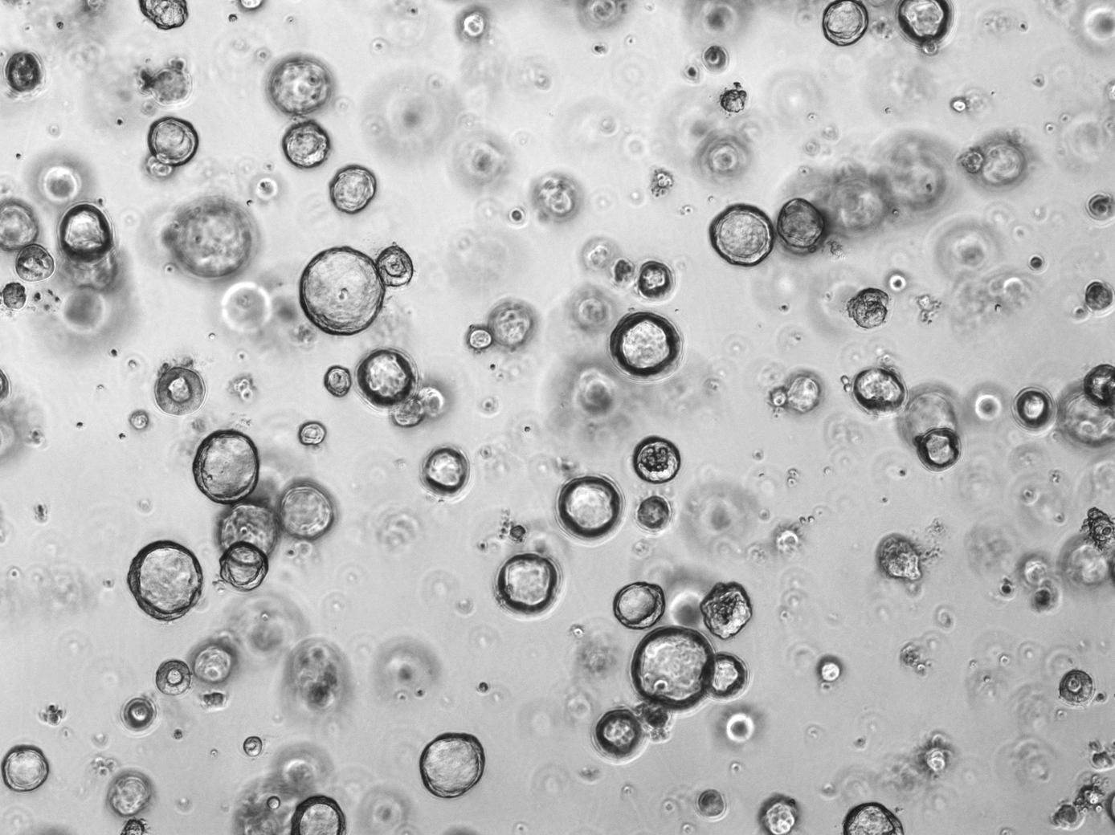
NKX2-1 SFTPC
Bright field

Figure 15
Brightfield image of AOs and same field on fluorescence. On D25 SFTPC⁺ (AT2) cells are already visible.

4.3 CO-CULTURE EXPERIMENTS
RVECs were expanded in EGM2 medium.
Co-culture of RVECs and AOs was performed in 24-transwell plate using expansion medium + FGF + heparin for 7 days and then substituted with differentiation medium + FGF + heparin + VEGF throughout all the co-culture. Transwells also allowed the creation of an air-liquid interface.
As cells grew and form AOs and tubules they formed a network of vessels surrounding the AOs and after 5-7 days of differentiation AOs showed markers of distal differentiation into alveolar type 1 and 2 cells, respectively Aquaporin5 (Aqp5) and Surfactant protein C (SFTPC). These data suggest that ECs play a pivotal role in AOs maturation and differentiation (as per Curradi et al. and Lee et al.) (figure 16 a,b).
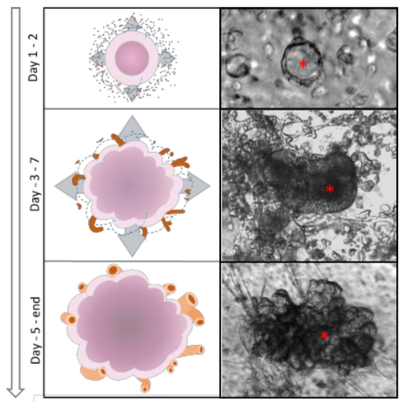a
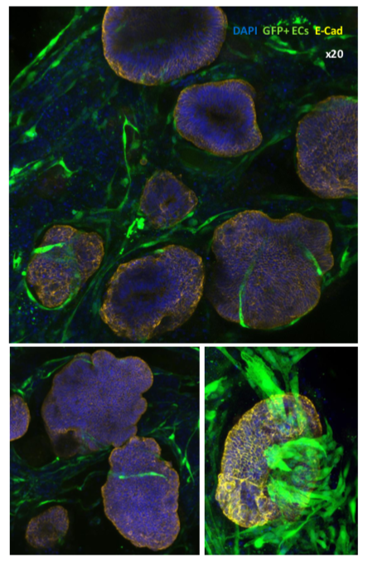b

Figure 16
Co-culture system:
- Representative drawings and brightfield pictures of the condensed co-culture method. Red asterisk: organoid. Magnification: x20
- Wholemount staining of human epithelial and human endothelial condensed co-cultures in Matrigel. Magnification: 20x.

- CONCLUSIONS
With our experiments we optimized an already established protocol for Endothelial Cells generation, obtaining morphologically and functionally differentiated cells from amniotic fluid- derived iPSCs. Up-to-know we are performing functional assays of hiPSC-derived ECs to assess tubule formation efficiency compared to RVECs.
Using already generated RVECs, we could perform a proof-of-concept experiment in which we demonstrated the feasibility of endothelial/epithelial co-culture.
In fact, the integration of both AOs and ECs generated from patient-derived iPSCs opens the way for a future establishment of a patient-specific 3D model of disease.

- REFERENCES

[1] Moore KL, Persaud TVN, Torchia MG. The Developing Human.Clinically oriented embryology. 9th edition.
[2] Udan RS, Culver JC, Dickinson ME. Understanding vascular development: WIRE Developmental Biology (2012). Wiley Interdiscip Rev Dev Biol. 2013 ; 2(3): 327–346. doi:10.1002/wdev.91.
[3] Tsikis ST, Hirsch TI, Fligor SC, Quigley M and Puder M (2022), Targeting the lung endothelial niche to promote angiogenesis and regeneration: A review of applications. Front. Mol. Biosci. 9:1093369. doi: 10.3389/fmolb.2022.1093369.
[4] Thébaud B, Goss KN, Laughon M, Whitsett JA, Abman SH, Steinhorn RH, Aschner JL, Davis PG, McGrath-Morrow SA, Soll RF, Jobe AH. Bronchopulmonary dysplasia. Nat Rev Dis Primers. 2019 Nov 14;5(1):78. doi: 10.1038/s41572-019-0127-7. PMID: 31727986; PMCID: PMC6986462.
[5] Zepp JA, Morley MP, Loebel C, Kremp MM, Chaudhry FN, Basil MC, Leach JP, Liberti DC, Niethamer TK, Ying Y, Jayachandran S, Babu A, Zhou S, Frank DB, Burdick JA, Morrisey EE. Genomic, epigenomic, and biophysical cues controlling the emergence of the lung alveolus. Science. 2021 Mar 12;371(6534):eabc3172. doi: 10.1126/science.abc3172. PMID: 33707239; PMCID: PMC8320017.
[6] Leiby KL, Raredon MSB, Niklason LE. Bioengineering the Blood-gas Barrier. Compr Physiol. 2020 Mar 12;10(2):415-452. doi: 10.1002/cphy.c190026. PMID: 32163210; PMCID: PMC7366783.
[7] Dunnill MS. Postnatal growth of the lung. Thorax 17: 329–333, 1962.
[8] Burri P. Fetal and postnatal development of the lung. Annu Rev Physiol 46: 617–628, 1984. [PubMed: 6370120]
[9] Schittny JC, Mund SI, Stampanoni M. Evidence and structural mechanism for late lung alveolarization. Am J Physiol Lung Cell Mol Physiol 294: L246–L254, 2008. [PubMed: 18032698]
[10] Miscia, M. E., Simeone, P., Bologna, G., Lanuti, P., Lisi, G., Pierdomenico, L., Di Renzo, D., Marchisio, M., Miscia, S., & Lelli Chiesa, P. (2022). Circulating endothelial cells and endothelial-derived vesicles identification in patients with infantile hemangioma: preliminary results of a prospective cohort study. Italian Journal of Anatomy and Embryology, 126(2), 87–91. https://doi.org/10.36253/ijae-13833.
[11] Ikuno T, Masumoto H, Yamamizu K, Yoshioka M, Minakata K, Ikeda T, et al. (2017) Efficient and robust differentiation of endothelial cells from human induced pluripotent stem cells via lineage control with VEGF and cyclic AMP. PLoS ONE 12(3): e0173271. https://doi.org/ 10.1371/journal.pone.0173271.
[12] Trillhaase, A., Maertens, M., Aherrahrou, Z. et al. Induced Pluripotent Stem Cells (iPSCs) in Vascular Research: from Two- to Three-Dimensional Organoids. Stem Cell Rev and Rep 17, 1741–1753 (2021). https://doi.org/10.1007/s12015-021-10149-3
[13] Palikuqi, B., Nguyen, DH.T., Li, G. et al. Adaptable haemodynamic endothelial cells for organogenesis and tumorigenesis. Nature 585, 426–432 (2020). https://doi.org/10.1038/s41586-020-2712-z
[14] He Y, Rofaani E, Huang X, Huang B, Liang F, Wang L, Shi J, Peng J, Chen Y. Generation of Alveolar Epithelium Using Reconstituted Basement Membrane and hiPSC-Derived Organoids. Adv Healthc Mater. 2022 Mar;11(6):e2101972. doi: 10.1002/adhm.202101972. Epub 2022 Jan 7. PMID: 34935309.
[15] Orlova, V., van den Hil, F., Petrus-Reurer, S. et al. Generation, expansion and functional analysis of endothelial cells and pericytes derived from human pluripotent stem cells. Nat Protoc 9, 1514–1531 (2014). https://doi.org/10.1038/nprot.2014.102.
[16] Lanuti P, Rotta G, Almici C, Avvisati G, Budillon A, Doretto P, Malara N, Marini M, Neva A, Simeone P, Di Gennaro E, Leone A, Falda A, Tozzoli R, Gregorj C, Di Cerbo M, Trunzo V, Mollace V, Marchisio M, Miscia S. Endothelial progenitor cells, defined by the simultaneous surface expression of VEGFR2 and CD133, are not detectable in healthy peripheral and cord blood. Cytometry A. 2016 Mar;89(3):259-70. doi: 10.1002/cyto.a.22730. Epub 2015 Aug 25. PMID: 26305912.
[17] Takahashi, K., Tanabe, K., Ohnuki, M., Narita, M., Ichisaka, T., Tomoda, K., & Yamanaka, S. (2007). Induction of pluripotent stem cells from adult human fibroblasts by defined factors. Cell, 131(5), 861–872. https://doi.org/10.1016/j.cell.2007.11.019.
[18] Choi, K.-D., Yu, J., Smuga-Otto, K., Salvagiotto, G., Rehrauer, W., Vodyanik, M., Thomson, J., & Slukvin, I. (2009). Hematopoietic and endothelial differentiation of human induced pluripotent stem cells. Stem Cells, 27(3), 559–567. https://doi.org/10.1002/stem. 20080922.
[19] Taura, D., Sone, M., Homma, K., Oyamada, N., Takahashi, K., Tamura, N., Yamanaka, S., & Nakao, K. (2009). Induction and isolation of vascular cells from human induced pluripotent stem cells—Brief report. Arteriosclerosis, Thrombosis, and Vascular Biology, 29(7), 1100–1103. https://doi.org/10.1161/ATVBAHA. 108.182162.
[20] Park, S.-W., Koh, Y. J., Jeon, J., et al. (2010). Efficient differenti- ation of human pluripotent stem cells into functional CD34 pro- genitor cells by combined modulation of the MEK/ERK and BMP4 signaling pathways. Blood, 116(25), 11.
[21] Homma, K., Sone, M., Taura, D., Yamahara, K., Suzuki, Y., Takahashi, K., Sonoyama, T., Inuzuka, M., Fukunaga, Y., Tamura, N., Itoh, H., Yamanaka, S., & Nakao, K. (2010). Sirt1 plays an important role in mediating greater functionality of human ES/iPS-derived vascular endothelial cells. Atherosclerosis, 212(1), 42–47. https://doi.org/10.1016/j.atherosclerosis.2010.04.021.
[22] Palpant, N. J., Pabon, L., Friedman, C. E., Roberts, M., Hadland, B., Zaunbrecher, R. J., Bernstein, I., Zheng, Y., & Murry, C. E. (2017). Generating high-purity cardiac and endothelial derivatives from patterned mesoderm using human pluripotent stem cells. Nature Protocols, 12(1), 15–31. https://doi.org/10.1038/nprot. 2016.153.
[23] Jacob A, Vedaie M, Roberts DA, Thomas DC, Villacorta-Martin C, Alysandratos KD, Hawkins F, Kotton DN. Derivation of self-renewing lung alveolar epithelial type II cells from human pluripotent stem cells. Nat Protoc. 2019 Dec;14(12):3303-3332. doi: 10.1038/s41596-019-0220-0. Epub 2019 Nov 15. PMID: 31732721; PMCID: PMC7275645.
[24] Gotoh S, Ito I, Nagasaki T, Yamamoto Y, Konishi S, Korogi Y, Matsumoto H, Muro S, Hirai T, Funato M, Mae S, Toyoda T, Sato-Otsubo A, Ogawa S, Osafune K, Mishima M. Generation of alveolar epithelial spheroids via isolated progenitor cells from human pluripotent stem cells. Stem Cell Reports. 2014 Sep 9;3(3):394-403. doi: 10.1016/j.stemcr.2014.07.005. Epub 2014 Aug 21. PMID: 25241738; PMCID: PMC4266003.
[25] Kanagaki S, Ikeo S, Suezawa T, Yamamoto Y, Seki M, Hirai T, Hagiwara M, Suzuki Y, Gotoh S. Directed induction of alveolar type I cells derived from pluripotent stem cells via Wnt signaling inhibition. Stem Cells. 2021 Feb;39(2):156-169. doi: 10.1002/stem.3302. Epub 2020 Nov 26. PMID: 33241896; PMCID: PMC7898721.
[26] Leiby, K. L., Ng, R., Campbell, S. G., Niklason, L. E. Engineered Lung Tissues Prepared from Decellularized Lung Slices. J. Vis. Exp. (179), e63151, doi:10.3791/63151 (2022).
[27] Lim K, Donovan APA, Tang W, Sun D, He P, Pett JP, Teichmann SA, Marioni JC, Meyer KB, Brand AH, Rawlins EL. Organoid modeling of human fetal lung alveolar development reveals mechanisms of cell fate patterning and neonatal respiratory disease. Cell Stem Cell. 2023 Jan 5;30(1):20-37.e9. doi: 10.1016/j.stem.2022.11.013. Epub 2022 Dec 8. PMID: 36493780.

